Finding a maximum matching in a circular-arc graph
Y. Daniel Liang, Chongkye Rhee
Information Processing Letters 45(1993)185-190

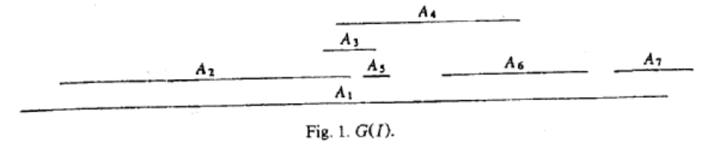
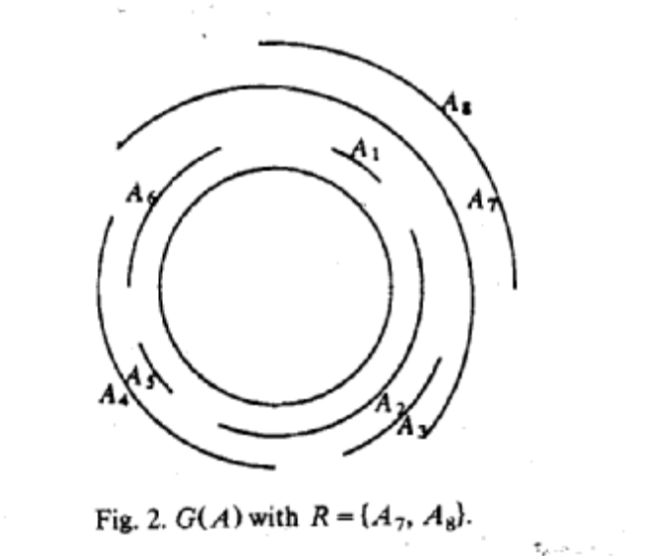
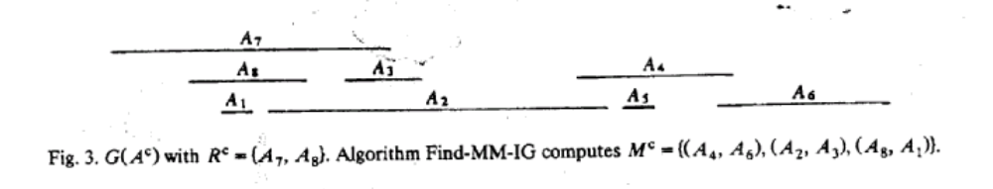
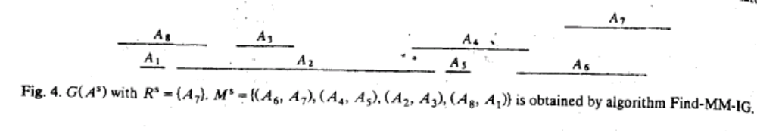
Created by: Sin-Huei Wu
Date : Apri. 25, 2001

